**ABHI Content Guidelines**

These guidelines are designed to ensure the ABHI website has a consistent look and feel. Standardised in design, in order that we may convey a unified message.

It is important you submit your content on time and in full by the required date, late content may cause a delay to the website launch or result in your content being omitted.

Please follow the guidelines below when creating your content, so we can ensure the website is a fantastic resource for our members, and showcases our work to all stakeholders.

**Audience**

Please look at our member persona (attached), and consider the site visitors aims, goals and how he/she wants to access and view the information you are going to provide. Ensure you are clear about the objective of every page and what you are trying to say. Be clear in what you convey, and try to be as concise as possible. Research has shown that our existing site is too text heavy. Try to convey information in different formats (such as video, infographic, diagram, table etc.), please let Communications know and they will arrange to help you to create new material.

**Words**

Target word count per page is 300. The maximum word count is 400. Please use headers and bullets where appropriate to separate the text into sections. If you need more space, segment the information to create separate webpages for each one. Ensure the tone is professional throughout. Do not use acronyms, unless you have first provided the full explanation of what it stands for. Standard English Oxford spelling should be adopted at all times, and use of modern equivalents such as “L@@k” instead of “Look” should be avoided at all times. Text colour, font and size will be standardised, so don’t worry about that. Please refrain from underlining or using a bold font unless it is a heading or title, as this could confuse the reader into thinking it is a hyperlink.

Don’t include any confidential information, and please run a spell check before you submit.

**Links**

Feel free to add links to other pages (just colour code where the links are, and add notes to tell the website builder where they are to link to.) Highlight the main text rather adding link text. For example: -

**Do this**: the **code of business practice website** has a wealth of resources you may find useful.

**Not this:** the code of business practice website has a wealth of resources you may find useful. For more information **click here**.

**Additional Features**

The ABHI website has a refreshed look and feel. An image is included for your reference. This is to demonstrate the overall concept – so please ignore content and minor detail. However please read the annotations – these highlight some features you may want to include in your pages such as highlighted quotes and link boxes.

**Format**

Please submit your text in a word document, using a separate word document for each page. Please save the document using the name of the page as the title of the document. These can be sent via email to Communications.

If you have any comments, suggestions or questions please contact Katryna ([katryna@pilgrimconsultancy.co.uk](mailto:katryna@pilgrimconsultancy.co.uk)).

Thanks for your contribution!

**New Site Look and Feel**

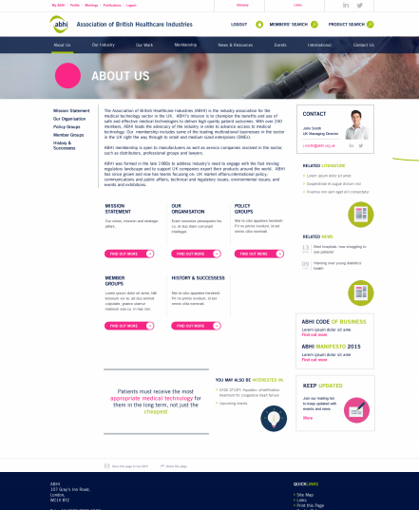

Links to other pages

You might also be interested in

Highlighted Quote